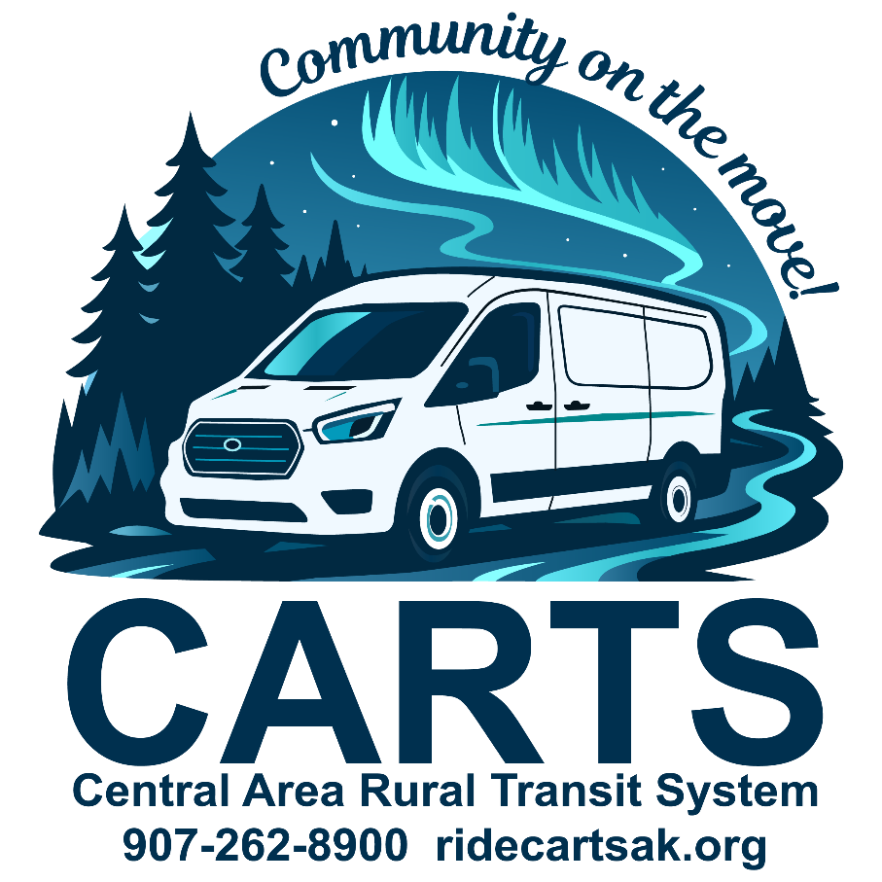

Rider Guide

CARTS takes you where you need to go!

Safe, reliable transportation that connects you to your community.

*Revised 09/29/25*

**Table of Contents**

Welcome to CARTS! 1

What is CARTS? 1

Contact Us! 1

Door-To-Door Service 2

Service Area 3

Ride Cost & Payment 5

Virtual Wallet 5

Ride Delivery Hours 6

Holidays 6

CARTS Vehicles 7

CARTS Pickup Window 8

Mobile App 9

Service Closures 10

Medical Emergencies 12

Lost Items 12

Parcels 12

Tipping 12

Animals 12

Rules of the Road 13

Cancellation & No-Show Policy 16

Rider Suspension Policy (other than No-Shows) 17

Americans with Disabilities Act (ADA) 19

Keeping in Touch 20

All Are Welcome to Ride CARTS 21

Special Thanks 22

# Welcome to CARTS!

Use this guide to successfully ride CARTS. If you have any additional questions, please check our website, [ridecartsak.org](https://ridecartsak.org/), or contact us.

# What is CARTS?

Central Area Rural Transit System, Inc. (CARTS) is the public transportation provider for the Central Kenai Peninsula.

CARTS provides safe, convenient public transportation services within the cities of Soldotna and Kenai, the communities of Funny River, Kasilof, Nikiski, Sterling, and all areas in between. We operate Monday through Saturday, 24 hours a day. Call us for a ride today. **We're going your way!**

# Contact Us!

Central Area Rural Transit System, Inc.

35139 K B Drive

Soldotna, AK 99669

P.O. Box 993 Soldotna, AK 99669

Email: [cartsinfo@ridecartsak.org](mailto:cartsinfo@ridecartsak.org)

## Important Phone Numbers

Office ................................(907) 262-8900

Cancellation Line .............(907) 262-3838

Fax ...................................(907) 262-6122

# Door-To-Door Service

CARTS provides door-to-door service – this means you must meet the driver at the front door of your home or the main door, main level or first floor of a building for an escort to the vehicle.

Please be ready to board the vehicle upon arrival. For safety and security reasons, drivers are not to leave sight of their vehicle by entering private homes and buildings, or go to rooms to pick up riders. Facility staff should be ready to assist the individual in and out of the building, if necessary.

Drivers do not carry people, mobility devices or packages. If this level of assistance is required, CARTS recommends traveling with someone who can assist you.

CARTS provides public transportation. We do not provide specialized care. Drivers deploy lifts for persons using mobility devices and those without mobility devices who cannot navigate the vehicle steps. Drivers also secure wheelchairs and, if in a wheelchair, fasten seatbelts. If additional assistance is needed, CARTS recommends traveling with someone who can assist you.

## Boarding Wheelchairs and Other Mobility Devices

CARTS will make every attempt to accommodate your wheelchair. Wheelchairs larger or that exceed the weight or size limits of our wheelchair lifts or ramps may be denied service. Please be sure that wheelchairs, or other mobility devices, are clean, safe and in good working condition before traveling. Wheelchairs are required to be secured.

# Service Area

CARTS service area includes Kasilof, Kenai, Soldotna, Sterling, Nikiski and all points between.

#### There are thirteen zones:

Funny River Road West Soldotna City Limits to Mile 8

Funny River Road East Mile 8 to end of road

Kasilof Irish Hills to North End Cohoe L00p

KBeach East College Loop to Bridge Access

KBeach West Bridge Access to Mile 8 KBeach

Kenai 4 Lane to Mile 15

Kenai Spur Highway Churchill Avenue to 4 Lane

North Nikiski Mile 29 to end of road

Soldotna Boundary to College Loop

South Nikiski Mile 15 to Mile 29

Sterling Bings Landing to Whisper

Sterling Highway North Whisper Lake to Boundary

Sterling Highway South Skyview to Irish Hills

**\*Note: The information listed above is for descriptive purposes only and may not be exact. For more information contact the CARTS office.**

**\*Note: The information depicted in this map is for a graphical representation only and may not be exact. For more information contact the CARTS office.**

# Ride Cost & Payment

Passengers are charged **one punch per zone traveled**. Quick stopovers along the direct route (post office, bank, etc.) are free. Each zone costs **$2.58, including tax**.

Rides must be **paid at the time of booking**; drivers cannot accept cash or cards.

# Virtual Wallet

CARTS offers a **Virtual Wallet** to make paying fares simple, safe, and convenient. When you book a trip, the fare is automatically reserved from your wallet and deducted once the trip is completed. If a trip is canceled or not provided, the fare is promptly returned to your account.

**Adding Funds:** You can add money to your wallet in multiple ways—**in person at the office, by phone, by mail, or online through the mobile app**. This allows you to pre-pay for rides in advance and travel with peace of mind.

**Linking a Credit Card:** For added convenience, you can securely link a credit card to your account through the mobile app. If you prefer, contact the office and we can set it up using an automated phone call.

**CARTS staff never have access to your stored card information, ensuring your payment details remain safe.**

# Ride Delivery Hours

CARTS provides rides Monday through Saturday, except for observed holidays.

# Holidays

The following is a list of holidays observed by CARTS:

**New Year's Day No service, office is closed**

**Memorial Day No service, office is closed**

**Independence Day No service, office is closed**

**Labor Day No service, office is closed**

**Thanksgiving No service, office is closed**

**Christmas Day No service, office is closed**

** When a holiday falls on a Sunday, the holiday is observed on Monday.

## Scheduling and Ride Reservation Hours

CARTS office hours are Monday through Saturday, 9 a.m. to 5 p.m. Rides need to be scheduled by 5pm the day prior.

Before taking your first trip, you’ll need to be added as a rider in our scheduling system. You can do this by phone, in the office, on our website, or through the mobile app.

Once you’re in the system, you can schedule rides in advance—whether it’s a week, a month, or even a year ahead. This makes it easy to plan regular trips for school, work, or other routines. If your plans change, just remember to cancel any rides you no longer need!

# CARTS Vehicles

CARTS operates a variety of vehicles, including passenger vans and accessible Ford Transits. All CARTS vehicles are clearly marked with our name and logo.

Our fleet is equipped with modern wheelchair restraints, ramps, and lifts, and our drivers are thoroughly trained in lift operation and wheelchair securement to ensure your safety and comfort.

In addition to our own vehicles, CARTS also partners with Alaska Cab. On some days, you may be transported by an Alaska Cab vehicle, which will also be clearly marked for your convenience.

Please let our dispatch know at the time of booking if you will need an accessible vehicle so we can ensure the right service is scheduled for you.



# CARTS Pickup Window

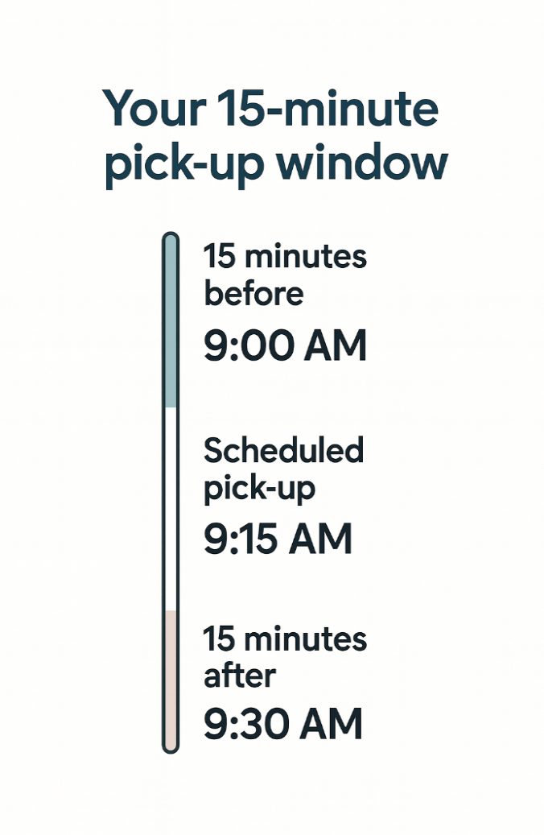

**15 minutes before 15 minutes after**

Please be ready 15 minutes before your scheduled pickup time. Vehicles run on a 15-minute window before and after your scheduled time. When the driver arrives, they can wait up to five minutes, so be prepared to leave right away. If you’re not ready to board within that time, the trip may be marked as a no-show.

Keep in mind that other riders may be sharing the vehicle, and the driver will have additional pickups and drop-offs after you’re on board. Boarding promptly helps keep everyone on schedule. During the winter, it’s a good idea to allow a little extra time for road conditions.

Trip times can vary depending on things like the number of passengers, daycare stops, traffic, and weather.

# Mobile App

The CARTS Dial-A-Ride app is available on the App Store and Google Play. With the app, you can schedule or cancel rides, add funds to your Virtual Wallet, link a credit card, and manage your trips with ease.

Stay connected with real-time updates, including ride confirmations, reminders (24 hours and 2 hours before your trip), driver en route, and driver arrival notifications. You’ll also receive alerts about weather closures or delays.

To receive prompt notifications, please ensure your account has a current phone number and that **(360) 634-0659** is saved in your contacts.

Simply scan the QR code to download the app and start riding smarter with CARTS!

**

# Service Closures

Scheduled transportation services may be altered and/or canceled due to a declared emergency or hazardous road or environmental conditions. CARTS may not operate under unsafe or hazardous conditions. If service is canceled or delayed all those with scheduled rides will be notified by phone as soon as possible.

## Definitions

1. **Declared emergency**: A localized, communitywide, statewide or nationwide catastrophic or hazardous event in which a local, state or federal governmental agency decrees a state of emergency and/or a decreed disaster area.
2. **Hazardous weather conditions**: Adverse road and/or environmental conditions that make it unsafe to operate the CARTS vehicles as advised by the National Weather Service, Alaska Department of Transportation and Public Facilities or Alaska State Troopers.

## Procedures

In a state of emergency, CARTS will cancel all scheduled rides until conditions allow restored transportation services. If the emergency is within a localized area, those rides may be canceled. CARTS will make every effort to contact passengers affected by the emergency. However, the nature of the emergency may not allow phone use. Passengers should be aware that under emergency situations, their ride may be canceled or altered without prior notification.

## Procedures Continued

In an adverse weather closure, CARTS will notify passengers, if possible, and cancel trips that have not begun. Passengers with scheduled rides are advised to listen to local radio stations for notification of transportation delays or cancelations. Passengers should be aware that under adverse road conditions, their ride may be canceled or altered without prior notification.

In both cases, CARTS will make all reasonable efforts to provide life sustaining (necessary medical treatment) transportation and return trips.

If the vehicle is not able to get to the curbside, or a mutually agreed pickup point, the trip may be canceled. If the driveway is not accessible by the vehicle, and/or the driver is unable to get to the door, door-to-door services may not be provided. It is the responsibility of the passenger to ensure that door-to-door service is accessible to the CARTS vehicle and driver.

# Medical Emergencies

CARTS drivers are certified in passenger assistance; however, they are not certified Emergency Medical Technicians (EMTs). In the event of an emergency, drivers will radio the dispatcher to call 911 for assistance and will wait for paramedics to arrive. For minor injuries or illnesses, drivers will take the passengers to the most appropriate location for care or assistance.

# Lost Items

CARTS is not responsible for lost or stolen items. When exiting the vehicle, please be sure to check around your seat to make sure you have all your belongings. If you do leave something on the vehicle, please call the office at (907) 262-8900 as soon as possible.

# Parcels

CARTS will make every effort to accommodate passengers that have parcels. If you are expecting to be carrying a large number of things with you, please let the office know when you schedule your ride. If there is any problem, it can be addressed at that time.

# Tipping

CARTS drivers may not accept tips. We appreciate the thought and encourage you to fill out a comment card or make a donation to the program instead. Visit our website to donate or ask your driver for a business card with the donation QR code.

# Animals

Animals, except for service animals, are not permitted on vehicles unless properly restrained. Service animals must be under the control of the passenger at all times.

# Rules of the Road

* + Everyone is eligible.
  + Drivers do not accept cash or card.
  + All rides are scheduled a day or more in advance.
  + Cancel trips no longer needed at least two hours in advance.
  + Children under the age seven cannot ride alone but do ride free with a caretaker.
  + A ride may be in a taxi or a CARTS van.
  + Passengers will probably share the vehicle with others.
  + Passengers may have to wait for a while and be ready.
  + Stops must be quick, since others are waiting. ALWAYS be considerate of others.
  + Smoking is not permitted on any CARTS vehicle.
  + Riders may not eat or drink on CARTS vehicles. Food and beverages will be allowed only in unopened containers.
* Hazardous items such as uncovered glass, gasoline, and other flammables and explosives are never allowed on public transportation vehicles or properties.
* All passengers and drivers are required to use a seat belt or approved child safety device. Drivers will not move the vehicle until everyone is safely secured. Young children riding CARTS must follow the State of Alaska seat belt law, which requires an approved child safety device (car seat or toddler booster seat). Specifically:

1. A child less than one year of age or a child one year of age or older who weighs less than 20 pounds shall be properly secured in a rear-facing child safety seat.
2. A child one or more years of age but less than five years of age who weighs 20 pounds or more shall be properly secured in a child restraint device.
3. A child over four years of age but less than eight years of age who is less than 57 inches in height and weighs 20 or more pounds but less than 65 pounds shall be properly secured in a booster seat that is secured by a seat belt system or by another child passenger restraint system.

* The child’s accompanying adult must provide a child restraint device for the child. The adult must secure the restraint device to the seat and ensure the child is secured before the vehicle moves. The driver may deny rides to children without appropriate restraint devices.
* Offensive language or behavior that is disruptive or unsafe for other riders or the driver is not allowed.
* Radios, audio devices and musical instruments cannot be operated unless earphones are used and the noise cannot be heard by the driver or by other passengers.
* Passengers must allow drivers to secure their wheelchairs.
* Driveways and walkways must be plowed and shoveled to allow for safe access and a reasonable turnaround area. If your driveway is not plowed, you will be asked to walk out to meet the vehicle.
* CARTS provides door-to-door service for passengers from the entry doorway to the vehicle. The driver can only go as far as the entry of a building. If a person requires assistance beyond an entry to a building, the passenger needs to provide their own attendant.
* A Personal Care Attendant (PCA) is someone who is physically and mentally able to assist a passenger when they require assistance beyond door-to-door service or needs to travel with the passenger for safety and health reasons. Both the PCA and the rider must be picked up and dropped off at the same address.

# Cancellation & No-Show Policy

A “No-Show” occurs when a rider who has a confirmed ride scheduled does not use the transportation within five minutes of vehicle arrival.

If you reserve a ride and decide not to travel, you must call to cancel your service at least two hours before your requested travel time. Any cancellation received less than two hours before the scheduled pickup time will be considered a “No-Show”. **If the first scheduled trip is logged as a “No-Show” the return trip is automatically cancelled.**

No-Shows are very costly to CARTS. Before you reserve a ride, be certain of your travel plans. Excessive No-Shows are considered an abuse of the system and will result in penalties and/or suspension of service***.***

### The following is CARTS No-Show Policy

Your transportation is scheduled in the CARTS system to meet your specific needs. You will only be allowed two (2) No Shows. After this point, a review will be done regarding the reasons for missing your rides. CARTS transportation has the right to decline your rides.

* + One No-Show results in a verbal warning.
  + Two No-Shows will result in a one-week Suspension from CARTS.
  + Three No-Shows will result in a one-month Suspension from CARTS.

#### CARTS has a Cancellation Line that is operational outside normal business hours!

Just call (907) 262-3838 and a customer service representative will help you. Remember, the cancellation line is only for ride cancellations. For any other issues please call (907) 262-8900 during regular business hours.

# Rider Suspension Policy (other than No-Shows)

CARTS has made a commitment to provide quality public transportation service to anyone on the central Kenai Peninsula who needs a ride. CARTS will make every reasonable effort to accommodate riders’ various conditions. However, there are rare occasions where the service is abused by individual riders. When this occurs repeatedly, it may be necessary to deny service to those individuals.

## Criteria for the suspension of service

* + **Verbal or physical abuse** towards a CARTS employee or passenger.
  + **Behavior** which represents a clear and present danger to an individual’s health or safety or of others within the vehicle. Such behavior includes conduct which is violent, seriously disruptive, or illegal.
  + **Lateness** not being ready at the scheduled pickup time. Rules require passengers to be ready 15 minutes before the scheduled pickup time as the vehicle has a 15-minute pickup window on either side of your scheduled time. Be prepared to leave when the vehicle arrives. Drivers are required to wait only five minutes upon arrival. If you have not boarded within the five-minute arrival time, your ride will be labeled as a no-show.

## Procedure

The following procedure will be followed before denying any transportation for any individual. All communications to the individual will be in an appropriate accessible format.

1. CARTS staff may immediately refuse service to an individual when necessary to protect the health and safety of other passengers or CARTS employees.
2. Incidents will be carefully and completely documented.
3. CARTS will provide notice of each infraction. This notice will include an explanation of the policy which the passenger has failed to follow. Notice will be provided of any proposed action, including suspension of service, resulting from the infraction.
4. With the exception of an infraction involving behavior which presents a danger to the individual or others using CARTS, passengers will receive three notices of infraction prior to the suspension of service.
5. The second notice will be a warning of impending suspension of service following the next occurrence of the infraction.
6. If corrective action does not occur, a third notice will be given to officially notify the individual of the suspension of service, and the date and duration of the suspension of service.

# Americans with Disabilities Act (ADA)

## Accessibility

CARTS is accessible to individuals with disabilities. Our buses and vans are equipped with wheelchair lifts or ramps that enable persons in wheelchairs or persons who cannot navigate steps to ride. Buses have priority seating at the front of the bus for individuals with disabilities. Operators are trained to assist riders use lifts and ramps and secure wheelchairs. You may travel with your respirator, concentrator, and portable oxygen. Service animals are welcome onboard buses and vans and in our facilities. (They must be kept under the control of the passenger at all times.) Public information is available in alternative accessible formats upon request. To request information in an alternative accessible format, please call us at (907) 262-900 or email us at [cartsinfo@ridecartsak.org](mailto:cartsinfo@ridecartsak.org). For your safety we will secure your wheelchair.

## Reasonable Modification Requests

Passengers with disabilities can request reasonable modifications to CARTS policy to enable them to ride the service. Passengers making requests are not required to use the term “reasonable modification.” Please call (907) 262-8900 to request the accommodation at least the day before you travel. The transit manager will review all requests and provide the determination.

In addition, CARTS accepts on-the-spot requests. For on-the-spot requests, the driver will contact dispatch. Dispatch will contact the transit manager.

## Public Information

Public information is available in alternative accessible formats upon request. To make a request, please call us at (907) 262-8900 or email us at [cartsinfo@ridecartsak.org.](mailto:cartsinfo@ridecartsak.org.) Please submit requests at least the day before the trip.

# Keeping in Touch

In order for CARTS to serve the community better, we work to constantly upgrade and improve our services. The public is always invited to call us to inquire about any of our services. We are here to serve the public, and no question is too big or too small! We welcome all questions and suggestions.

## How do I make my comments known?

We want to know how you feel about our service. Each compliment is shared with the employees involved. Each suggestion or complaint is investigated and discussed with the appropriate employee(s). Remember, CARTS can only address those issues we are made aware of. **Call the CARTS supervisor at (907) 262-8900 with your comments or email comments to** [**cartsinfo@ridescartsak.org.**](mailto:cartsinfo@ridescartsak.org) **Comments can also be submitted through our website at** [**www.ridecartsak.org**](http://www.ridecartsak.org/).

You may also write to CARTS at the address provided below. Please be as specific as possible and include the following information:

* + Your name, address, and phone number
  + The date and time of the incident
  + The CARTS vehicle number and/or driver’s name
  + Your compliment, suggestion or complaint

If you have an unresolved problem or question contact:

CARTS Executive Director and/or Board President

PO Box 993

Soldotna, AK 99669

# All Are Welcome to Ride CARTS

CARTS operates its programs and services without regard to race, color national origin or disability in accordance with Title VI of the 1964 Civil Rights Act and the Americans with Disabilities Act (ADA) of 1990.

Any person who believes that he or she has been aggrieved by any unlawful discriminatory practice under Title VI or ADA may file a complaint with us. Any such complaint must be in writing and filed with this agency within 180 days following the date of the alleged discriminatory occurrence.

For more information on our nondiscrimination obligations or how to file a complaint, please contact CARTS by any of the methods listed below.

Executive Director

Central Area Rural Transit System, Inc. (CARTS)

P.O. Box 993 Soldotna, AK 99669

(907) 262-8900

(907) 262-6122 fax

[cartsinfo@ridecartsak.org](mailto:cartsinfo@ridecartsak.org)

The complaint form and instructions are also available on our website, [ridecartsad.org](https://ridecartsak.org/).

If this information is needed in another language, please contact us. Request a complaint form by calling (907) 262-8900.

# Special Thanks

CARTS would like to thank everyone that rides with our service, and we encourage your continued support. Only by keeping transit in the public eye can we hope to ensure the future of public transit in our area.

CARTS would also like to thank the Kenai Peninsula Borough, the City of Soldotna, the City of Kenai, plus all the local agencies and organizations that help us in our endeavor to provide public transportation to the central Kenai Peninsula.

Last, but certainly not least, CARTS would like to thank our dedicated employees, and contract providers. They are the heart of the service!