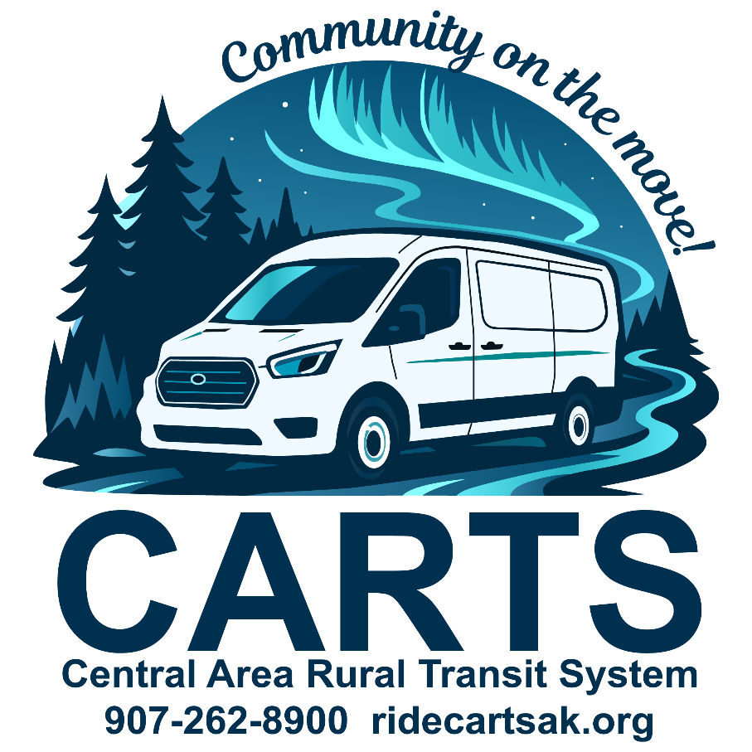

Rider Guide

CARTS takes you where you need to go!
Safe, reliable transportation that connects you to your community.
Revised 09/26/25

Table of Contents
Welcome to CARTS! 1
What is CARTS? 1
Contact Us! 1
Door-To-Door Service 2
Service Area 3
Ride Cost & Payment 5
Virtual Wallet 5
Ride Delivery Hours 6
Holidays 6
CARTS Vehicles 7
CARTS Pickup Window 8
Mobile App 9
Service Closures 10
Medical Emergencies 12
Lost Items 12
Parcels 12
Tipping 12
Animals 12
Rules of the Road 13
Cancellation & No-Show Policy 16
Rider Suspension Policy (other than No-Shows) 17
Americans with Disabilities Act (ADA) 19
Keeping in Touch 20
All Are Welcome to Ride CARTS 21
Special Thanks 22

Welcome to CARTS!
Use this guide to successfully ride CARTS. If you have any additional questions, please check our website, ridecartsak.org, or contact us.

What is CARTS?
Central Area Rural Transit System, Inc. (CARTS) is the public transportation provider for the Central Kenai Peninsula.
CARTS provides safe, convenient public transportation services within the cities of Soldotna and Kenai, the communities of Funny River, Kasilof, Nikiski, Sterling, and all areas in between. We operate Monday through Saturday, 24 hours a day. Call us for a ride today. We're going your way!

Contact Us!
Central Area Rural Transit System, Inc.
35139 K B Drive
Soldotna, AK 99669
P.O. Box 993 Soldotna, AK 99669
Email: cartsinfo@ridecartsak.org

Important Phone Numbers
Office ................................(907) 262-8900
Cancellation Line .............(907) 262-3838
Fax ...................................(907) 262-6122

Door-To-Door Service
CARTS provides door-to-door service, meaning riders must meet the driver at the front door of their home or the main entrance on the main level or first floor of a building for escort to the vehicle. Please be ready to board when the vehicle arrives. Drivers will wait up to five (5) minutes after arrival before departing.

For safety and security reasons, drivers cannot leave sight of the vehicle by entering private homes or buildings or going to individual rooms to locate riders. If needed, facility staff should assist riders to and from the main entrance.

Drivers do not carry passengers, mobility devices, or packages. If this level of assistance is required, CARTS recommends traveling with someone who can provide assistance.

CARTS provides public transportation and does not offer specialized care. Drivers deploy lifts for riders using mobility devices and for those unable to navigate vehicle steps. Drivers secure wheelchairs and fasten seatbelts when riders remain seated in their mobility device. If additional assistance is needed, CARTS recommends traveling with a companion.

Boarding Wheelchairs and Other Mobility Devices
CARTS will make every attempt to accommodate your wheelchair. Wheelchairs larger or that exceed the weight or size limits of our wheelchair lifts or ramps may be denied service. Please be sure that wheelchairs, or other mobility devices, are clean, safe and in good working condition before traveling. Wheelchairs are required to be secured.

Service Area
CARTS provides service throughout Kasilof, Kenai, Soldotna, Sterling, Nikiski, and all points in between.

Service Zones:
Funny River Road West Soldotna City Limits to Mile 8
Funny River Road East Mile 8 to end of road
Kasilof Irish Hills to North End Cohoe L00p
KBeach East College Loop to Bridge Access
KBeach West Bridge Access to Mile 8 KBeach
Kenai 4 Lane to Mile 15
Kenai Spur Highway Churchill Avenue to 4 Lane
North Nikiski Mile 29 to end of road
Soldotna Boundary to College Loop
South Nikiski Mile 15 to Mile 29
Sterling Bings Landing to Whisper
Sterling Highway North Whisper Lake to Boundary
Sterling Highway South Skyview to Irish Hills

*Note: The information listed above is for descriptive purposes only and may not be exact. For more information contact the CARTS office.

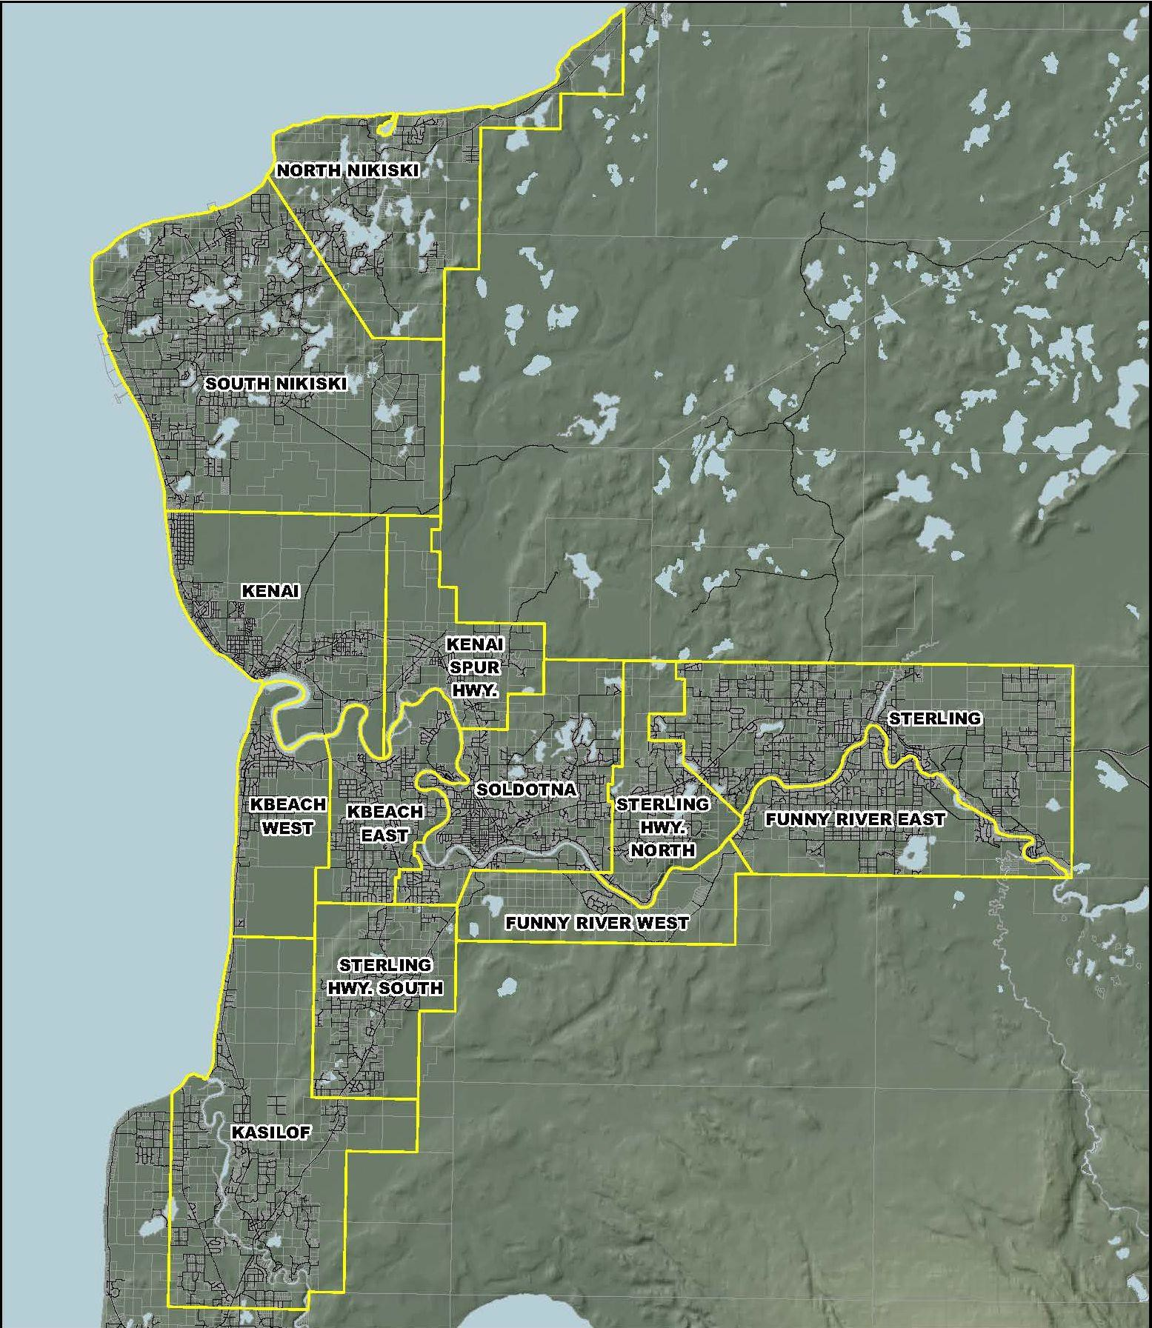

*Note: The information depicted in this map is for a graphical representation only and may not be exact. For more information contact the CARTS office.

Ride Cost & Payment
Passengers are charged one punch per zone traveled. Each zone costs $2.58 (tax included).

One stopover of five (5) minutes or less is allowed at no additional charge if it is along the direct route of travel (for example, a quick stop at the post office or bank). Only one free stopover is permitted. If multiple stops are needed, they must be scheduled in advance and will be charged accordingly.

Rides must be paid at the time of booking; drivers cannot accept cash or card payments.

Virtual Wallet
CARTS offers a Virtual Wallet to make paying fares simple, safe, and convenient. When you book a trip, the fare is automatically reserved from your wallet and deducted once the trip is completed. If a trip is canceled or not provided, the fare is promptly returned to your account.

Adding Funds: You can add money to your wallet in multiple ways—in person at the office, by phone, by mail, or online through the mobile app. This allows you to pre-pay for rides in advance and travel with peace of mind.

Linking a Credit Card: For added convenience, you can securely link a credit card to your account through the mobile app. If you prefer, contact the office and we can set it up using an automated phone call.

CARTS staff never have access to your stored card information, ensuring your payment details remain safe.

Ride Delivery Hours
CARTS provides rides Monday through Saturday, except for observed holidays.

Holidays
The following is a list of holidays observed by CARTS:
New Year's Day No service, office is closed
Memorial Day No service, office is closed
Independence Day No service, office is closed
Labor Day No service, office is closed
Thanksgiving No service, office is closed
Christmas Day No service, office is closed
** When a holiday falls on a Sunday, the holiday is observed on Monday.

Scheduling and Ride Reservation Hours
CARTS office hours are Monday through Saturday, 9am to 5pm. Rides need to be scheduled by 5pm the day prior.
Before taking your first trip, you’ll need to be added as a rider in our scheduling system. You can do this by phone, in the office, on our website, or through the mobile app.
Once you’re in the system, you can schedule rides in advance—whether it’s a week, a month, or even a year ahead. This makes it easy to plan regular trips for school, work, or other routines. If your plans change, just remember to cancel any rides you no longer need!

CARTS Vehicles
CARTS operates a variety of vehicles, including passenger vans and accessible Ford Transits. All CARTS vehicles are clearly marked with our name and logo.
Our fleet is equipped with modern wheelchair restraints, ramps, and lifts, and our drivers are thoroughly trained in lift operation and wheelchair securement to ensure your safety and comfort.
In addition to our own vehicles, CARTS also partners with Alaska Cab. On some days, you may be transported by an Alaska Cab vehicle, which will also be clearly marked for your convenience.
Please let our dispatch know at the time of booking if you will need an accessible vehicle so we can ensure the right service is scheduled for you.

CARTS Pickup Window
15 minutes before 15 minutes after
Please be ready about 15 minutes before your scheduled pickup time. Vehicles operate within a 15-minute window before and after the scheduled time. When the driver arrives, they will wait up to five minutes, so riders must be ready to board promptly.

If a rider is not ready within that time, the trip may be marked as a no-show.

To receive real-time updates about driver arrival, make sure the correct notification method is selected in your account. Notifications can be sent by text message, phone call, or through the rider mobile app.

Trip times may vary depending on factors such as the number of passengers, daycare stops, traffic, weather, and shared rides with other passengers.

Mobile App
The CARTS Dial-A-Ride app is available on the App Store and Google Play. With the app, you can schedule or cancel rides, add funds to your Virtual Wallet, link a credit card, and manage your trips with ease.
Stay connected with real-time updates, including ride confirmations, reminders (24 hours and 2 hours before your trip), driver en route, and driver arrival notifications. You’ll also receive alerts about weather closures or delays.
To keep receiving notifications, please make sure your account always has a current phone number.
Simply scan the QR code to download the app and start riding smarter with CARTS!


Service Closures
Scheduled transportation services may be altered and/or canceled due to a declared emergency, hazardous road or environmental conditions. CARTS may not operate under unsafe or hazardous conditions. If service is canceled or delayed all those with scheduled rides will be notified by phone as soon as possible.

Definitions
- Declared emergency: A localized, communitywide, statewide or nationwide catastrophic or hazardous event in which a local, state or federal governmental agency decrees a state of emergency and/or a decreed disaster area.
- Hazardous weather conditions: Adverse road and/or environmental conditions that make it unsafe to operate the CARTS vehicles as advised by the National Weather Service, Alaska Department of Transportation and Public Facilities or Alaska State Troopers.

Procedures
In a state of emergency, CARTS will cancel all scheduled rides until conditions allow restored transportation services. If the emergency is within a localized area, those rides may be canceled. CARTS will make every effort to contact passengers affected by the emergency. However, the nature of the emergency may not allow phone use. Passengers should be aware that under emergency situations, their ride may be canceled or altered without prior notification.

Procedures Continued
In an adverse weather closure, CARTS will notify passengers, if possible, and cancel trips that have not begun. Passengers with scheduled rides are advised to listen to local radio stations for notification of transportation delays or cancelations. Passengers should be aware that under adverse road conditions, their ride may be canceled or altered without prior notification.
In both cases, CARTS will make all reasonable efforts to provide life sustaining (necessary medical treatment) and return trips.
If the vehicle is not able to get to the curbside, or a mutually agreed pickup point, the trip may be canceled. If the driveway is not accessible by the vehicle, and/or the driver is unable to get to the door, door-to-door services may not be provided. It is the responsibility of the passenger to ensure that door-to-door service is accessible to the CARTS vehicle and driver.

Medical Emergencies
CARTS drivers are certified in passenger assistance; however, they are not certified Emergency Medical Technicians (EMTs). In the event of an emergency, drivers will radio the dispatcher to call 911 for assistance and will wait for paramedics to arrive. For minor injuries or illnesses, drivers will take the passengers to the most appropriate location for care or assistance.

Lost Items
CARTS is not responsible for lost or stolen items. When exiting the vehicle, please be sure to check around your seat to make sure you have all your belongings. If you do leave something on the vehicle, please call the office at (907) 262-8900 as soon as possible.

Parcels
CARTS will make every effort to accommodate passengers that have parcels. If you are expecting to be carrying a large number of things with you, please let the office know when you schedule your ride. If there is any problem, it can be addressed at that time.

Tipping
CARTS drivers may not accept tips. We appreciate the thought and encourage you to fill out a comment card or make a donation to the program instead. Visit our website to donate. CARTS accepts Venmo. Please ask your driver for a business card with the Venmo QR code.

Animals
Animals, except for service animals, are not permitted on vehicles unless housed in closed containers. Service animals must be under the control of the passenger at all times.

Rules of the Road
  - Everyone is eligible.
  - Drivers do not accept cash or card.
  - All rides are scheduled a day or more in advance.
  - Cancel trips that are no longer needed at least two hours in advance.
  - Children under the age seven cannot ride alone but do ride free with a caretaker.
  - Passengers will probably share the vehicle with others.
  - Stops must be quick, since others are waiting. ALWAYS be considerate of others.
  - Smoking is not permitted on any CARTS vehicle.
  - Riders may not eat or drink on CARTS vehicles. Food and beverages will be allowed only in unopened containers.
- Firearms and hazardous items such as uncovered glass, gasoline and other flammables and explosives are never allowed on public transportation vehicles or properties. Only law enforcement officers may bring weapons on public transportation vehicles or property.
- All passengers and drivers are required to use a seat belt or approved child safety device. Drivers will not move the vehicle until everyone is safely secured. Young children riding CARTS must follow the State of Alaska seat belt law, which requires an approved child safety device (car seat or toddler booster seat).

Specifically:
- A child less than one year of age or a child one year of age or older who weighs less than 20 pounds shall be properly secured in a rear-facing child safety seat.
- A child one or more years of age but less than five years of age who weighs 20 pounds or more shall be properly secured in a child restraint device.
- A child over four years of age but less than eight years of age who is less than 57 inches in height and weighs 20 or more pounds but less than 65 pounds shall be properly secured in a booster seat that is secured by a seat belt system or by another child passenger restraint system.
- The child’s accompanying adult must provide a child restraint device for the child. The adult must secure the restraint device to the seat and ensure the child is secured before the vehicle moves. The driver may deny rides to children without appropriate restraint devices.
- Offensive language or behavior that is disruptive or unsafe for other riders or the driver is not allowed.
- Radios, audio devices and musical instruments cannot be operated unless earphones are used and the noise cannot be heard by the driver or by other passengers.
- Passengers must allow drivers to secure their wheelchairs.
- Driveways and walkways must be plowed and shoveled to allow for safe access and a reasonable turnaround area. If your driveway is not plowed, you will be asked to walk out to meet the vehicle.
- CARTS provides door-to-door service for passengers from the entry doorway to the vehicle. The driver can only go as far as the entry of a building. If a person requires assistance beyond an entry to a building, the passenger needs to provide their own attendant.
- A Personal Care Attendant (PCA) is someone who is physically and mentally able to assist a passenger when they require assistance beyond door-to-door service or needs to travel with the passenger for safety and health reasons. Both the PCA and the rider must be picked up and dropped off at the same address. PCAs ride free of charge with CARTS.

Cancellation & No-Show Policy
A “No-Show” occurs when a rider with a confirmed trip does not board the vehicle within five minutes of arrival.
If you no longer need your ride, you must cancel at least two hours before the scheduled pickup time. Cancellations made less than two hours before pickup will be recorded as a No-Show. If the first trip of the day is a No-Show, the return trip will be automatically canceled.
Repeated No-Shows are considered misuse of the service and may result in penalties or suspension.

The following is CARTS No-Show Policy
  - One No-Show results in a verbal warning.
  - Two No-Shows will result in a one-week Suspension from CARTS.
  - Three No-Shows will result in a one-month Suspension from CARTS.
If a rider accumulates more than three No-Shows within a 90-day period, CARTS may review the rider’s trip history to determine the cause of the missed trips. Riders who demonstrate a pattern of repeated No-Shows may be subject to additional suspensions or service restrictions. If further action is warranted, CARTS will attempt to contact the rider using the phone number on file to discuss the issue prior to implementing a suspension. CARTS reserves the right to refuse service when repeated No-Shows interfere with the efficient operation of the service.

CARTS has a Cancellation Line that is operational outside normal business hours!
Just call (907) 262-3838 and a customer service representative will assist you. Please note the cancellation line is for ride cancellations only. For any other issues, call (907) 262-8900 during regular business hours.

Rider Suspension Policy (other than No-Shows)
CARTS has made a commitment to provide quality public transportation service to anyone on the central Kenai Peninsula who needs a ride. CARTS will make every reasonable effort to accommodate riders’ various conditions. However, there are rare occasions where the service is abused by individual riders. When this occurs repeatedly, it may be necessary to deny service to those individuals.

Criteria for the suspension of service
• Verbal or physical abuse toward a CARTS employee or passenger.
• Behavior that represents a clear and present danger to the health or safety of the individual or others in the vehicle. Such behavior includes conduct that is violent, seriously disruptive, or illegal.
• Personal hygiene or sanitary conditions that create a health or safety concern for other passengers or the driver.

Procedure
The following procedure applies to violations of CARTS policies related to rider conduct, safety, or misuse of service. This procedure does not apply to missed trips. No-shows are addressed separately under the CARTS No-Show Policy. All communication with the individual will be provided in an appropriate accessible format.

- CARTS staff may immediately refuse or suspend service when necessary to protect the health and safety of passengers or CARTS employees.
- All incidents will be documented thoroughly, including the date, description of the incident, and any actions taken.
- CARTS will provide written notice for each policy violation. The notice will explain the policy that was violated and any potential action that may result, including suspension of service.
- Except in cases involving behavior that presents an immediate safety risk, passengers will receive up to three notices before service is suspended.
- The first notice serves as documentation of the violation.
- The second notice serves as a warning that continued violations may result in suspension of service.
- If the behavior continues, a third notice will be issued informing the individual of the suspension of service, including the start date and duration of the suspension.
- CARTS reserves the right to suspend or refuse service when repeated violations interfere with safe and efficient operations.

Americans with Disabilities Act (ADA)

Accessibility
CARTS is accessible to individuals with disabilities. Our buses and vans are equipped with wheelchair lifts or ramps that enable persons in wheelchairs or persons who cannot navigate steps to ride. Buses have priority seating at the front of the bus for individuals with disabilities. Operators are trained to assist riders use lifts and ramps and secure wheelchairs. You may travel with your respirator, concentrator, and portable oxygen. Service animals are welcome onboard buses and vans and in our facilities. (They must be kept under the control of the passenger at all times.) Public information is available in alternative accessible formats upon request. To request information in an alternative accessible format, please call us at (907) 262-900 or email us at cartsinfo@ridecartsak.org. For your safety we will secure your wheelchair.

Reasonable Modification Requests
Passengers with disabilities can request reasonable modifications to CARTS policy to enable them to ride the service. Passengers making requests are not required to use the term “reasonable modification.” Please call (907) 262-8900 to request the accommodation at least the day before you travel. The transit manager will review all requests and provide the determination.
In addition, CARTS accepts on-the-spot requests. For on-the-spot requests, the driver will contact dispatch. Dispatch will contact the transit manager.

Public Information
Public information is available in alternative accessible formats upon request. To make a request, please call us at (907) 262-8900 or email us at cartsinfo@ridecartsak.org. Please submit requests at least the day before the trip.

Keeping in Touch
In order for CARTS to serve the community better, we work to constantly upgrade and improve our services. The public is always invited to call us to inquire about any of our services. We are here to serve the public, and no question is too big or too small! We welcome all questions and suggestions.

How do I make my comments known?
We want to know how you feel about our service. Each compliment is shared with the employees involved. Each suggestion or complaint is investigated and discussed with the appropriate employee(s). Remember, CARTS can only address those issues we are made aware of. Call the CARTS supervisor at (907) 262-8900 with your comments or email comments to cartsinfo@ridescartsak.org. Comments can also be submitted through our website at www.ridecartsak.org.
You may also write to CARTS at the address provided below. Please be as specific as possible and include the following information:
  - Your name, address, and phone number
  - The date and time of the incident
  - The CARTS vehicle number and/or driver’s name
  - Your compliment, suggestion or complaint
If you have an unresolved problem or question contact:
CARTS Executive Director and/or Board President
PO Box 993
Soldotna, AK 99669

All Are Welcome to Ride CARTS
CARTS operates its programs and services without regard to race, color national origin or disability in accordance with Title VI of the 1964 Civil Rights Act and the Americans with Disabilities Act (ADA) of 1990.
Any person who believes that he or she has been aggrieved by any unlawful discriminatory practice under Title VI or ADA may file a complaint with us. Any such complaint must be in writing and filed with this agency within 180 days following the date of the alleged discriminatory occurrence.
For more information on our nondiscrimination obligations or how to file a complaint, please contact CARTS by any of the methods listed below.
Executive Director
Central Area Rural Transit System, Inc. (CARTS)
P.O. Box 993 Soldotna, AK 99669
(907) 262-8900
(907) 262-6122 fax
cartsinfo@ridecartsak.org
The complaint form and instructions are also available on our website, ridecartsak.org.
If this information is needed in another language, please contact us. Request a complaint form by calling (907) 262-8900.

Special Thanks
CARTS would like to thank everyone who rides and supports our service. Your continued support helps keep public transportation visible and ensures it remains available in our community.

We also extend our appreciation to City of Soldotna, City of Kenai, Rasmuson Foundation, Kenai Peninsula Foundation, Aurora Foundation, Department of Health and Social Services, Denali Commission, DOT&PF, and the many local agencies and community partners that support our efforts to provide public transportation throughout the central Kenai Peninsula.

Finally, we would like to thank our dedicated employees and contract providers. Their commitment and hard work are the heart of CARTS.

